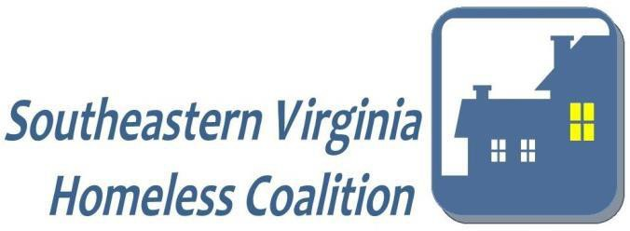
Homelessness will be Rare, Brief, and Non-Recurring.
AGENDA
GoTo Meeting
August 11, 2021
12:30 PM – 2:00 PM

- Welcome and Introductions L. Dixon & M. Chick-Ebey

- Program Spotlight:

- Project HOPE-VA Dr. Patricia Popp
- Virginia Veteran and Family Support Kim Wasserberg & Marcus Brooks

- Business
- Emergency Housing Voucher Updates

- Governing Board Report L. Dixon & M. Chick-Ebey

- Roundtable Updates and Resources Members

- NEXT MEETING: October 13, 2021 at 12:30 p.m.
MEETING LOCATION: TBD

SVHC General Membership
Wed, Aug 11, 2021 12:30 PM - 2:00 PM (EDT)
Please join my meeting from your computer, tablet or smartphone.
https://global.gotomeeting.com/join/184407749
You can also dial in using your phone.
United States: +1 (312) 757-3121
Access Code: 184-407-749
New to GoToMeeting? Get the app now and be ready when your first meeting starts: https://global.gotomeeting.com/install/184407749

For any follow up information, or if you would like to be included on future agendas, please contact Shantelle Haggins at (757) 622-9268 ext. 3040 or by email: shaggins@theplanningcouncil.org

SVHC COMMITTEE GUIDE

Executive Committee | Chair: Michael Stultz  1st Vice-Chair: Michael Coffman  2nd Vice Chair: Sharon Waters | Conducts the business of the Coalition, proposes general policies and guidance, including adaptation of Bylaws, and ensures subcommittees are meeting project requirements. Meeting Schedule: 2nd Wednesday of every other month @ 2:00 p.m.  Location: South Norfolk Memorial Library, 801 Poindexter St., Suite 111, Chesapeake, VA
Program Monitoring Committee | Chair: Stacie Walls-Beegle Co-Chair: Kristen Pine | Provides year-round monitoring of funded homeless projects and ensures all adhere to funding requirements, informs providers of submission requirements, coordinates an unbiased review panel to prioritize annual projects and funding, and ensures that providers meet the established Standards of Care.  Meeting Schedule: 4th Wednesday of every month @ 12:30 noon  Location: The Planning Council, 5365 Robin Hood Road Suite 700, Norfolk, VA
Data Collection (HMIS) Committee | Chair: Juanita Dowdy | Provides oversight and guidance on issues related to the implementation of the Homeless Management Information System, ensures HMIS users meet the established Standards of Care.  Meeting Schedule: Quarterly, on the 2nd Tuesday of the month @ 10:00 a.m.  Location: ForKids, 4200 Colley Avenue, Norfolk, VA
Service Coordination Committee - Singles | Chairs: John Gugliemino and Carolsue McGehee | Works to address the needs of homeless individuals requiring a multitude of services through increasing coordination among housing providers and systems of care, focuses on shelter exits and securing permanent housing placements for clients, provides wrap around services for clients who cannot immediately access housing.  Meeting Schedule: Every other Wednesday at 9:00 a.m.  Location: TBD
Service Coordination Committee – Families | Chairs: Heather Barker and Nathan Ruckman | Works to address the needs of homeless families requiring a multitude of services through increasing coordination among housing providers and systems of care, monitors and facilitates the movement of families off of the shelter waiting list and into shelter or permanent housing placements by utilizing targeted referrals Meeting Schedule: Every Tuesday at 12:00 noon  Location: NDHS, 741 Monticello Avenue, Norfolk, VA

