

**Homeless and Special Needs Housing**

**Application Instructions**

**Housing Trust Fund - Homeless Reduction Grant**

**Due Date: December 7, 2020**

Questions regarding program or application should be directed to:

Aaron Shoemaker

(804) 371 – 7119

[aaron.shoemaker@dhcd.virginia.gov](mailto:aaron.shoemaker@dhcd.virginia.gov)

CAMS-related questions should be directed to:

CAMS HELP DESK

<CamsHelp@dhcd.virginia.gov>



**Homeless and Special Needs Housing Application**

The Homeless and Special Needs Housing (HSNH) application is a community-based application for the Virginia Homeless Solutions Program (VHSP) and Housing Opportunities for Persons With AIDS (HOPWA) funding and provides the collaborative framework for the Housing Trust Fund (HTF) portion of the application.

**Eligible Applicants**

Eligible applicants are units of local government, non-profit organizations or housing developers (non-profit and for-profit), Community Housing Development Organizations (CHDOs), single purpose organization or a limited liability corporation (LLC). If an LLC or development team is applying, the preferable applicant is the primary partner in the LLC or development team or the individual organization that will have the ongoing responsibility for the project.

Applicants must have a registered CAMS profile in order to apply. Proposed projects that will leverage multiple partners and subcontracts are allowable. The applicant is the entity responsible for compliance. Please contact DHCD if you have any questions.

DHCD may not enter into program contracts with any applicant with outstanding audit findings, IRS findings, DHCD monitoring findings or other compliance issues. Please note that DHCD will work with all interested parties toward the resolution of outstanding issues, where appropriate.

DHCD must verify project partner capacity and roles when evaluating applications and project feasibility. Applicants must be able to clearly articulate the relationship between all partners involved in the service provision, development, ownership, and/or property management of a project.

**Application Submission**

The Housing Trust Fund (HTF) Homeless Reduction Grant applications must be submitted through DHCD’s [Centralized Application and Management System](https://dmz1.dhcd.virginia.gov/camsportal/Login.aspx) (CAMS). Applicants should carefully follow all instructions for submission. Applications submitted with incorrect or missing information will be reviewed as is.

An applicant organization must have a registered CAMS organizational profile in order to apply for HTF funding. Once an organization has an approved profile, individual users may be given access to CAMS by the organization’s profile manager.

Applicants may submit applications at any time prior to the deadline. DHCD will only review applications submitted by the established deadline.

CAMS will send the applicant an email notification when an application has been submitted and received.

**Project Information**

The applicant must log into CAMS and select the Housing Trust Fund Homeless Reduction Grant Pool 2021 program, select the appropriate sub-program (HTF-HRG Rapid Rehousing and Innovation Projects or HTF-HRG Permanent Supportive Housing) and click Apply. When the applicant clicks on Apply the system will ask for a Project Name. Please be careful to enter a project name that will help DHCD identify your project. The name of the development or the street where the project is located would be appropriate project names. Once the applicant hits Continue the project name cannot be edited. At this point CAMS will give the application a system-generated Application ID number.

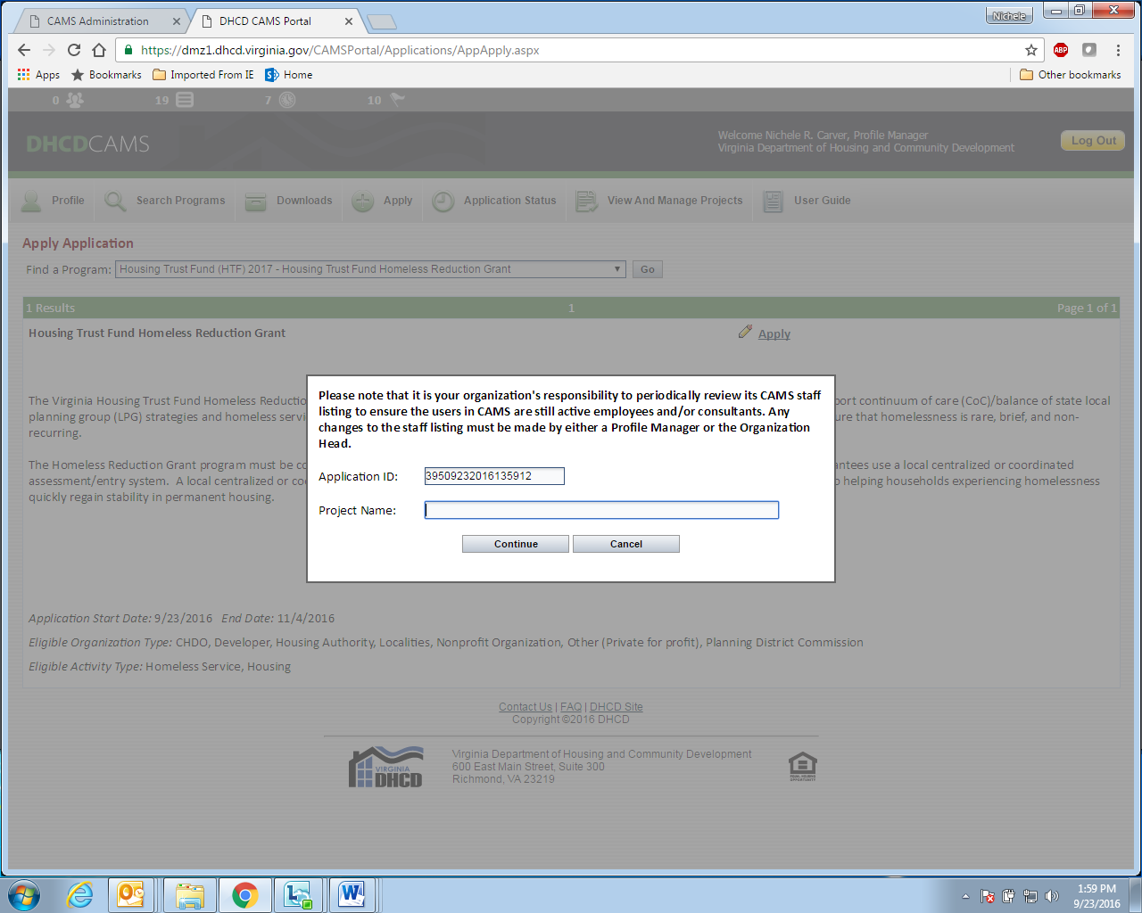

Select Continue and CAMS will take the applicant to the Project Information tab. On the project information tab the Organization Name will be pre-populated based on the organization’s profile. Please note, any errors or needed updates to the organizational profile must be made by the individual who is set up as a profile manager for your organization.

On the project information tab the applicant must enter the Project Primary Contact information. This is the name of the individual DHCD should contact with questions about the project and their contact information.

Place of Primary Performance is where that project will be located and the Primary Service Area is the locality(s) that the project is intended to target.

The page will display a ‘Print’ option at the top right-hand corner. The ‘Print’ function will produce a PDF that can be printed or saved. This will have any information that you have entered and saved in the application.

*Tip: To print an application that will display all the questions simply go into the “Narrative Information” tab and enter NA into each text box. This will allow you to have a copy of the application including all the narrative questions to work from outside of CAMS.*

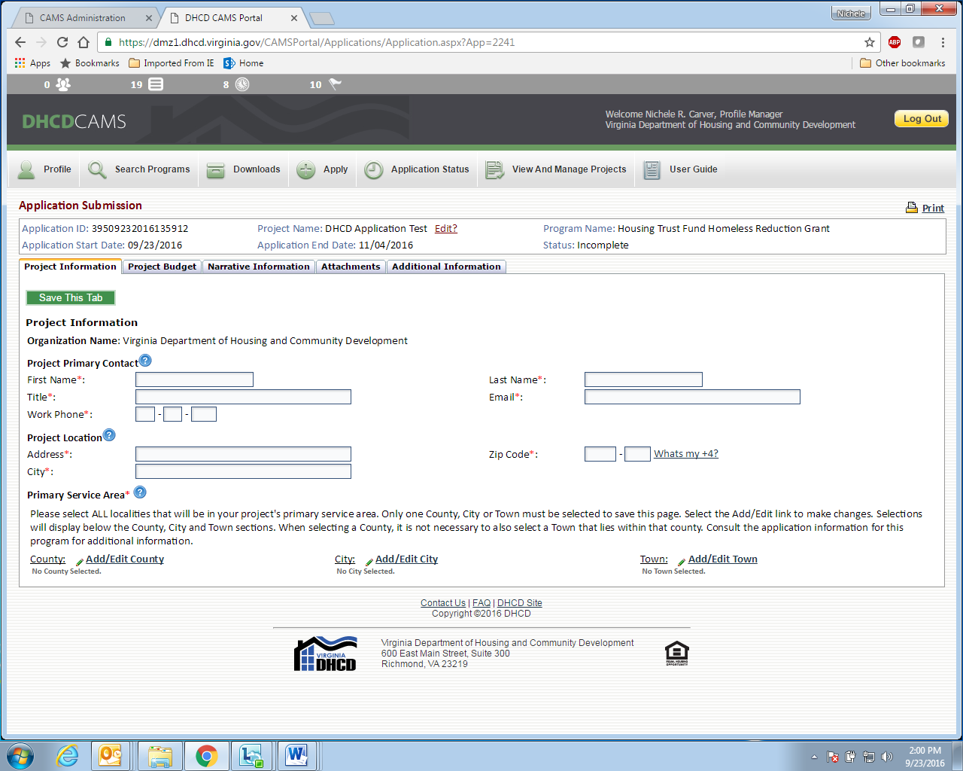

**Project Budget**

The next tab, Project Budget, requires basic budget information that corresponds to the requested amount and project type.

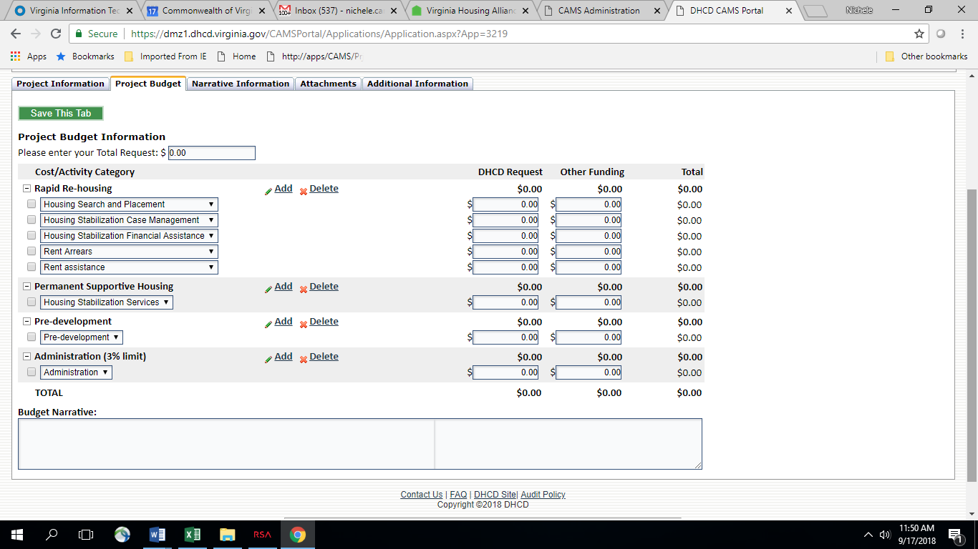

**Narrative Information**

The applicant will then go to the narrative questions. There are size limits to the text boxes. DHCD suggests that applicants work in Word and copy and paste into the CAMS text boxes. Word allows an applicant to spell check and check the size of the text prior to copying and saving in the text box. Once the narrative information is complete applicants should print the questions by clicking the Print tab at the top of the page and review them for completeness and accuracy. The applicant is able to edit this information up until the time the application is submitted for review.

The CAMS text box in this section will only accommodate text responses. Graphics, tables, and charts will appear as text only. The applicant may use the CAMS attachment section to provide any additional information not accommodated in the narrative text boxes.

**HSNH: Housing Trust Fund - Homeless Reduction Grant Application Narrative**

**Letter of Support - Local Coordination (All applicants)**

1. Detail the coordination between the CoC/LPG and applicant in the development of this project.
2. Describe how the proposed project fits within the community’s plan to prevent and end homelessness. Does this project fill an identified gap in services?
3. Describe how this project fits into the community’s COVID-19 response strategies and efforts. Will this project prioritize households newly engaged in emergency shelter through the increased availability of non-congregate shelter funding or other COVID-19 response resources?
4. Describe how this project fits into the local crisis response system.

**Need, Approach, + Capacity (RRH & Innovative Projects Only)**

1. Provide a clear description of the proposed project to include goals, program services to be funded with this grant, target population, and staffing. Proposed project must meet the requirements and expectations set forth by the HSNH program guidelines.
2. Summarize the funding request. What is the minimum amount of funding required to meet the stated need and intended outcomes of this project? The summary must list the total request for each budget activity and provide a detailed description of the proposed activities. The budget narrative must include the project location and the current status of project components either under development or in the process of being implemented. Please include the timeline for when staff funded by this grant will be hired.
3. If applicable, describe how this project will reduce the number of youth (age 18-24) and families experiencing homelessness.
4. Include information about how this project will prioritize high barrier households and serve vulnerable populations including the following: persons of color, sex offenders, large families, medically fragile, LGBTQ+, and unaccompanied youth.

Also address how your proposed project will ensure access for households with accessibility concerns including language and mobility and households with limited or no personal phone or internet access.

1. RRH Only – how will this funding build upon or complement existing RRH activities within CoC/LPG? If a currently existing project, how many households were served in the most recent program year.

Youth Only – Provide a clear description of how this application meets at least one of the core components and meets the expectations for youth involvement as stated in the HSNH guidelines.

Older Adults Only – Provide a clear description of the planning/coordinating body and whether this body is currently functioning or will be forming during this project implementation and meets the expectations for older adult involvement as stated in the HSNH guidelines.

1. Using relevant data, describe the unmet need in the community that this project is designed to address. Data sources may include but not be limited to: community and agency level data, HMIS data, PIT data, qualitative data, and other relevant sources.
2. How will your agency collect and use data to inform the project design, to make changes, and inform decisions? Include information about how you will evaluate outcomes and project performance.
3. Detail the coordination between the CoC/LPG and applicant in the development of this project.
4. Describe how community stakeholders and other homeless services providers were involved in the development and/or implementation of the project.
5. Describe how the proposed project fits within the community’s plan to prevent and end homelessness. Does this project fill an identified gap in services?
6. Describe how this project fits into the community’s COVID-19 response. Will this project prioritize households newly engaged in emergency shelter through the increased availability of non-congregate shelter funding or other COVID-19 response resources?
7. Describe how this project fits into the local crisis response system.
8. Describe how the project will be incorporated into the local coordinated assessment system. This must include a clear and appropriate method for individuals and families to access initial intake, evaluation, and services. (Youth projects) How are youth identified for services (include outreach and other partnerships) if not through CES. Once identified, how are youth then connected with CES?
9. If the proposed project was previously funded through the HTF-HRG, how did that funding change or improve services and meet a community need? Detail outcomes of that funding and intended outcomes of this proposed project including intended number of households served and cost per household. If the proposed project is a new project, what impact would this funding have on the previously stated need? Detail the intended outcomes of this proposed project including intended number of households served and cost per household (if applicable).
10. (RRH projects) Describe how the program is aligned with the National Alliance to End Homelessness Performance Benchmarks and Program Standards. Provide project-level data for the three benchmarks: average length of homelessness; exits to permanent housing; and returns to homelessness.
11. (Planning projects) Will the outcome be a new model of service or best practice that can be replicated elsewhere?
12. Has the agency evaluated its program services and outcomes data for racial disparities? If so, what were the results of those efforts and did the organization do anything with the data to effect change? Include changes in program design, outreach, assessment, provision of services, follow-up to ensure maintenance of stable housing, etc.
13. Describe how the project will implement housing stabilization services to ensure households are moved quickly into permanent housing and remain stably housed. Include a description of how households will be connected to mainstream resources. Please name partners specific to this project including but not limited to higher/secondary education, health care, workforce development, and financial support programs/income building programs.
14. Describe in detail how the organization implements a Housing First approach. Include specific examples such as organizational or programmatic policies, procedures, guidelines, etc.
15. Has the agency’s programs been previously monitored by state or federal funders? Were any concerns or significant issues discovered? Have any funds been returned due to monitorings or inability to spend funds within the contract period? If yes, please explain why and how the issue is being addressed.
16. Provide evidence of the organizational capacity of the applicant and any key partners including experience with similar projects and overall financial and management capacity. Describe any changes in leadership over the past year.

**Need, Approach, + Capacity (PSH Projects Only)**

1. Provide a clear description of the proposed project to include goals, program services to be funded with this grant, target population, and staffing. Proposed project must meet the requirements and expectations set forth by the HSNH program guidelines.
2. Summarize the funding request. What is the minimum amount of funding required to meet the stated need and intended outcomes of this project? The summary must list the total request for each budget activity and provide a detailed description of the proposed activities. The budget narrative must include the project location and the current status of project components either under development or in the process of being implemented. Please include the timeline for when staff funded by this grant will be hired.
3. If applicable, describe how this project will reduce the number of youth (age 18-24) and families experiencing homelessness.
4. Include information about how this project will prioritize high barrier households and serve vulnerable populations including the following: persons of color, sex offenders, large families, medically fragile, LGBTQ+, and unaccompanied youth. Also address how your proposed project will ensure access for households with accessibility concerns including language and mobility and households with limited or no personal phone or internet access.
5. How will this funding build upon or complement existing supportive housing activities within CoC/LPG? If a previously existing project, how many householders were served.
6. Using relevant data, describe the unmet need in the community that this project is designed to address. Data sources may include but not be limited to: community and agency level data, HMIS data, PIT data, qualitative data, and other relevant sources.
7. How will your agency collect and use data to inform the project design, to make changes, and inform decisions? Include information about how you will evaluate outcomes and project performance.
8. Detail the coordination between the CoC/LPG and applicant in the development of this project.
9. Describe how community stakeholders and other homeless services providers were involved in the development and/or implementation of the project.
10. Describe how the proposed project fits within the community’s plan to prevent and end homelessness. Does this project fill an identified gap in services?
11. Describe how this project fits into the community’s COVID-19 response. Will this project prioritize households newly engaged in emergency shelter through the increased availability of non-congregate shelter funding or other COVID-19 response resources?
12. Describe how this project fits into the local crisis response system.
13. Describe how the project will be incorporated into the local coordinated assessment system. This must include a clear and appropriate method for individuals and families to access initial intake, evaluation, and services.
14. If the proposed project was previously funded through the HTF-HRG, how did that funding change or improve services and meet a community need? Detail outcomes of that funding and intended outcomes of this proposed project including intended number of households served and cost per household. If the proposed project is a new project, what impact would this funding have on the previously stated need? Detail the intended outcomes of this proposed project including intended number of households served and cost per household (if applicable).
15. Describe contingency plan for serving households in this project if funding is terminated at the conclusion of this grant cycle.
16. Has the agency evaluated its program services and outcomes data for racial disparities? If so, what were the results of those efforts and did the organization do anything with the data to effect change? Include changes in program design, outreach, assessment, provision of services, follow-up to ensure maintenance of stable housing, etc.
17. Describe how the project will implement housing stabilization services to ensure households are moved quickly into permanent housing and remain stably housed. Include a description of how households will be connected to mainstream resources. Please name partners specific to this project including but not limited to higher/secondary education, health care, workforce development, and financial support programs/income building programs.
18. Does your community have strategies for moving households from permanent supportive housing into mainstream housing (ex. Move On strategies)? If this is an existing project, detail the effectiveness of this effort (i.e. how many households have been successfully transitioned into mainstream housing). Detail the partnerships between the CoC/LPG, grantee, and mainstream housing programs such as public housing, the Housing Choice Voucher program, and HUD-funded multifamily housing providers.
19. If your community does not currently have strategies for moving households from permanent supportive housing into mainstream housing (ex. Move On strategies), what efforts are being made to develop and implement strategies? Detail the partnerships between the CoC/LPG, grantee, and mainstream housing programs such as public housing, the Housing Choice Voucher program, and HUD-funded multifamily housing providers.
20. Describe in detail how the organization implements a Housing First approach. Include specific examples such as organizational or programmatic policies, procedures, guidelines, etc.
21. Has the agency’s programs been previously monitored by state or federal funders? Were any concerns or significant issues discovered? Have any funds been returned due to monitorings or inability to spend funds within the contract period? If yes, please explain why and how the issue is being addressed.
22. Provide evidence of the organizational capacity of the applicant and any key partners including experience with similar projects and overall financial and management capacity. Describe any changes in leadership over the past year.

**Attachments**

There are a number of attachments required for the Homeless Reduction Grant application. Some of these attachments require the use of a DHCD-provided template. The Certifications and Assurances is an example where the applicant will be required to download a template, complete, and upload the completed templates. All attachments are listed on the attachment tab. The attachments with required templates have a link next to the name of the attachment and instructions to download.

Some attachments do not require DHCD templates. Applicant Financials is an example of an attachment where the applicant will not be required to download and complete a DHCD template. In these cases the applicant would simply upload an electronic version of the document under the appropriate attachment.

Please see the [CAMS User Guide](https://www.dhcd.virginia.gov/sites/default/files/Docx/CAMS/URG-Table-Of-Contents.pdf) for more detailed instructions (file types and size limits).

Required application attachments include the following:

|  |  |
| --- | --- |
| **Application Attachments** | |
| ***Name of Attachment*** | ***Requirement*** |
| Certifications and Assurances* | DHCD template; required for all projects |
| Applicant Financials | Required for all projects – current and prior year organizational budgets to include revenue sources and expenses |
| Letter of Support (signed by the CoC/LPG governing board chair) | Required for all projects – letter should include detailed responses to all four questions. |
| CoC/LPG approved Homeless Services Flow Chart | Required for all projects |
| Job Descriptions | Required for projects proposing staff costs |
| MOUs | If applicable |
| Board of Directors | Required for non-profit applicants |
| Additional Attachments | Optional |

*DHCD required template

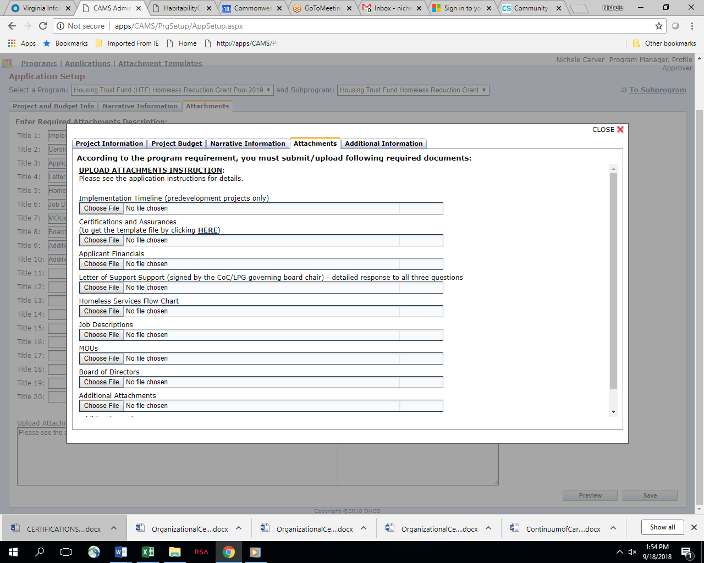

**Additional Information**

The Additional Information tab allows the applicant to provide additional information not previously requested in the other sections of the application.

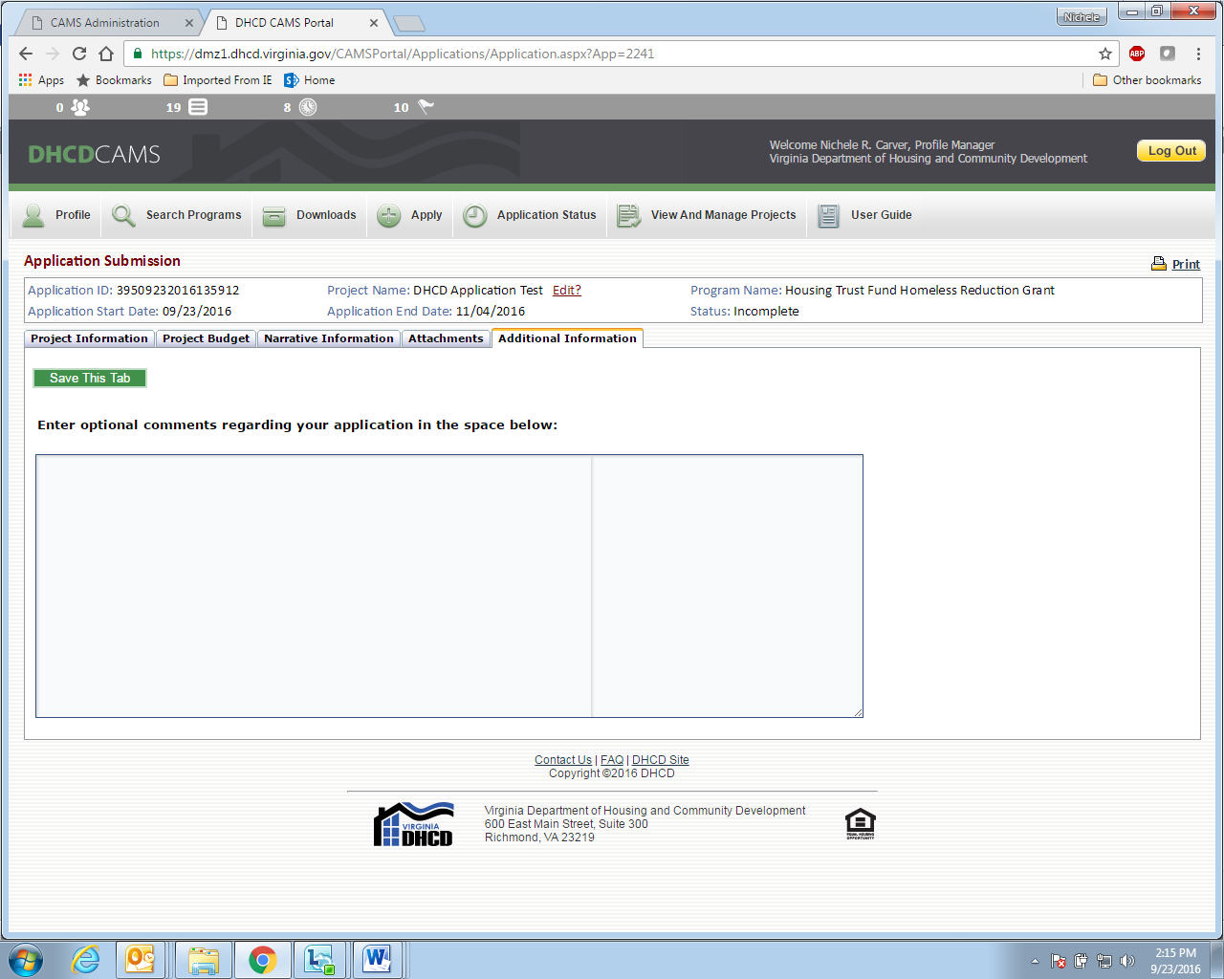

**Application Status**

Applicants may allow multiple users to edit and review application materials. Applicants are solely responsible for controlling security access to CAMS.

Once the applicant begins work on the application CAMS will save the application as Incomplete. The applicant may return repeatedly to CAMS to work on this application. Please be sure all work on the application is saved in CAMS. The application will remain as an incomplete application until the applicant chooses to submit the application. Once the application is submitted the status will change from Incomplete to Pending.

**DHCD Review Process**

Applicants with unresolved DHCD findings, audit findings, or other compliance issues will not be eligible for a funding commitment.

DHCD conducts panel reviews of all applications submitted by eligible applicants through CAMS.

Applications will be accepted on or before 11:59 PM, December 7, 2020 and ***must*** be submitted to DHCD through the online application and project management system, [CAMS](https://dmz1.dhcd.virginia.gov/camsportal/Login.aspx) (Centralized Application and Management System). Please allow up to two business days for responses to CAMS help desk requests.

Applications received by the deadline will be reviewed against established criteria to identify those projects best positioned to meet priority needs within Virginia.

Applications must meet minimum requirements including scoring at least 60 points in order to be considered for funding. Scoring criteria are need, approach, local coordination, and capacity.

Fifteen percent of the score will be based on Part I of the Homeless and Special Needs Housing 2020-2022 application.

Applications will be reviewed and scored by a panel. Offers will be extended to those applications scoring at least 60 points based on availability of funds. Any remaining balance of funds may be allocated through a subsequent application process.

Project applications selected through the Homeless Reduction Grant application process will receive funding notification in writing. Additional information and negotiations may be required prior to contract execution. Applicant awards are tentative pending an executed contract. Applicants are expected to respond in a timely manner to all information requests.

Additional information may be found in the [HSNH Program Guidelines](https://www.dhcd.virginia.gov/sites/default/files/Docx/vhsp/homeless-and-special-needs-housing-guidelines.pdf) and during the How-to-Apply webinars. Information for accessing webinars may be found on the [DHCD website.](http://www.dhcd.virginia.gov/index.php/dhcd-resources/trainings-and-workshops.html)